Westermo Usb Cable

The intent of this cable is to hook up a generic usb device to a westermo switch and upload or download its configuration file.

Parts

1. Male USB Type A receptacle with wires or a terminal board,
   1. ADAFRUIT.com pn xxxxxx or
   2. Digikey pn xxxxxxxx
2. M12 male A coded 5 position plug
   1. Digikey pn xxxxxxxx
3. 4 ferrules, light blue

Assembly

1. Put it togeather
2. Sketch out wire cut backs

Pinout

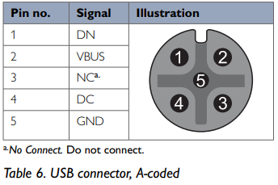M12 Wire color USB Name

1 grey 2 data -

2 red 1 VCC

4 green 3 data +

5 black 4 ground

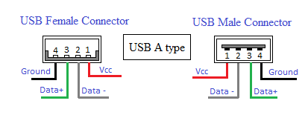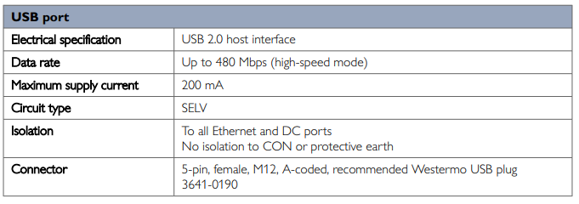

**Info from WEOS manual**

7.1.5.1 General information on using USB memory sticks In order to copy files to/from a USB memory stick attached to USB port of the WeOS product10, the USB memory stick must:  be partitioned with at least one partition of at least 4MiB  be formatted as EXT3, VFAT or FAT on the first partition As of WeOS v4.32.5 the following USB stick(s) are verified for use with WeOS products: Westermo USB stick 3641-0190 (Serial number 1195 or higher) for RedFox Rail and Viper, see user guides in section 1.5. 10For information on WeOS products equipped with a USB port, see section 1.5.1, or the User Guide of your WeOS product (see section 1.5). 110 © 2022 Westermo Network Technologies AB Westermo OS Management Guide Version 4.32.5-0 If a factory reset is conducted on the WeOS unit, only files on unit flash (configuration, IPsec certificates, etc.) will be affected by the factory reset. Files on an attached USB stick (if present) will not be affected